**HOW TO RUN Caclutor3 Api**

**Getting the Sources**

1.From terminal cd into your chosen workspace and clone the repository Calculator3 from github.

<https://github.com/kiptubei/Calculator3>

git clone <https://github.com/kiptubei/Calculator3.git>

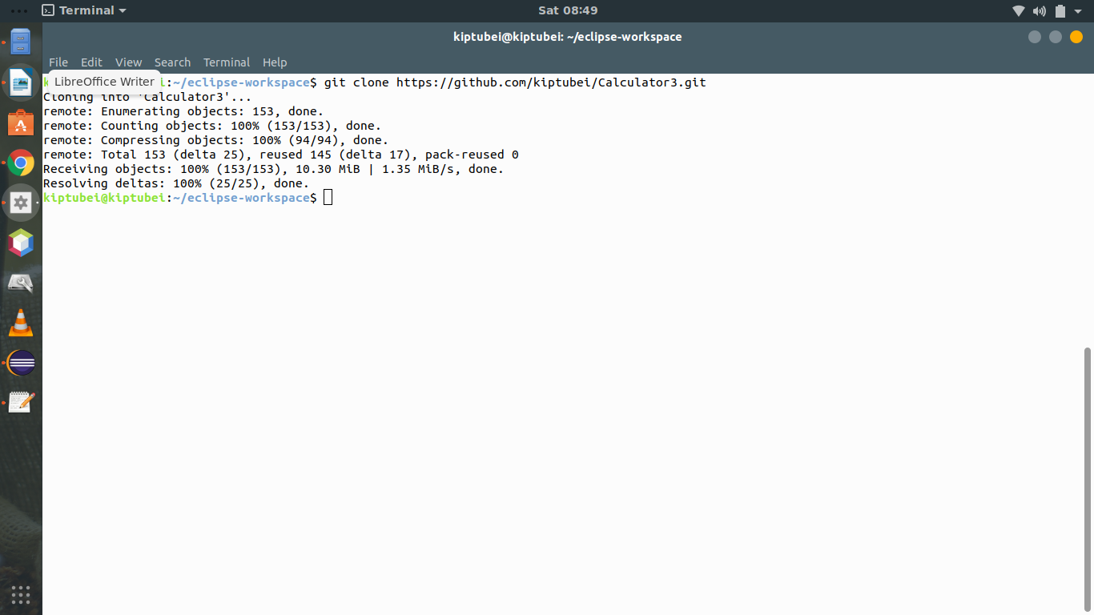

cd into Calculator3 and do a git pull

git pull origin master

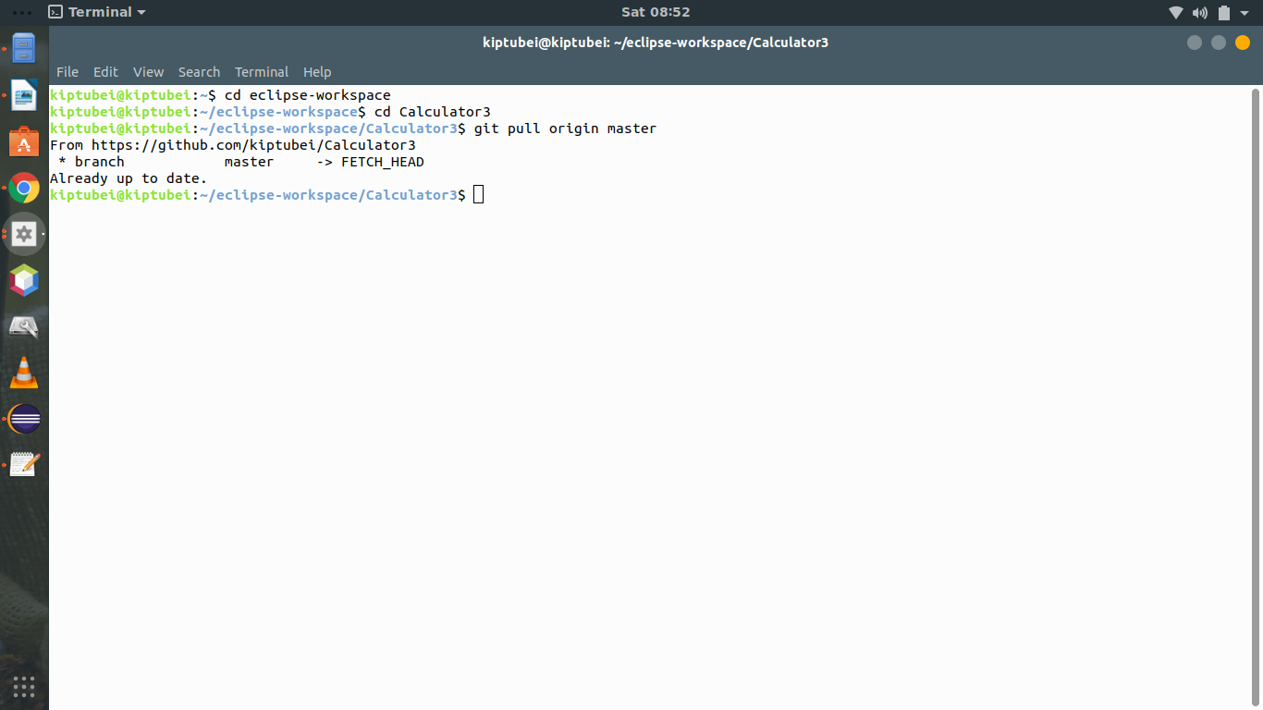

Confirm everything is ok with git status



**Running from Eclipse IDE**

From Eclipse IDE open the project.

File → Open Project from file system

Navigate to repository location and click Finish

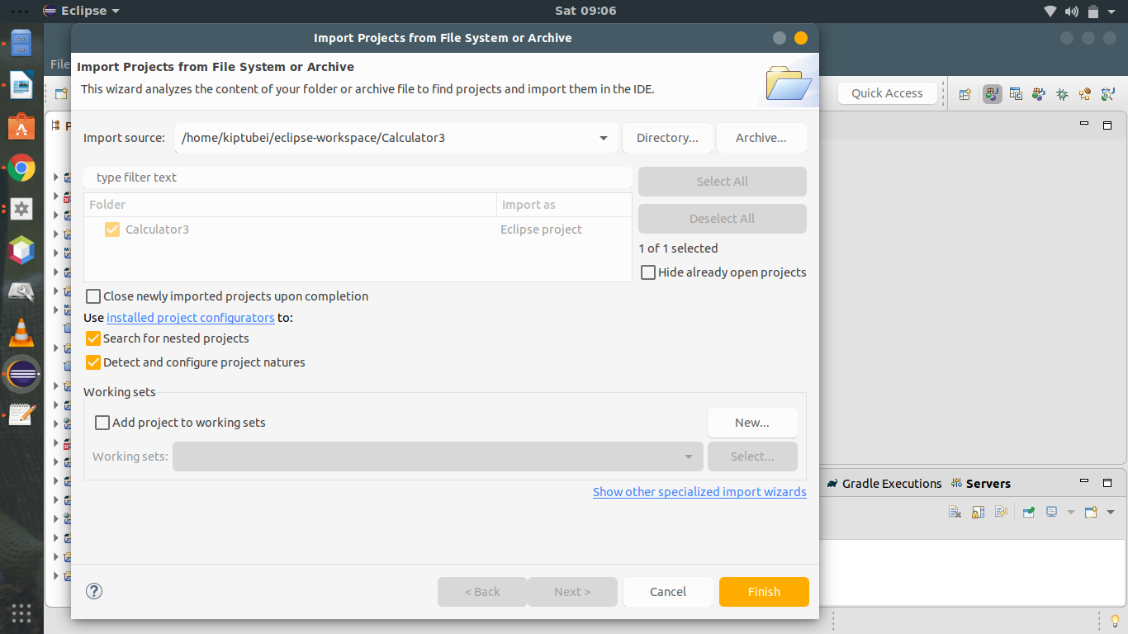

It should show up on your IDE

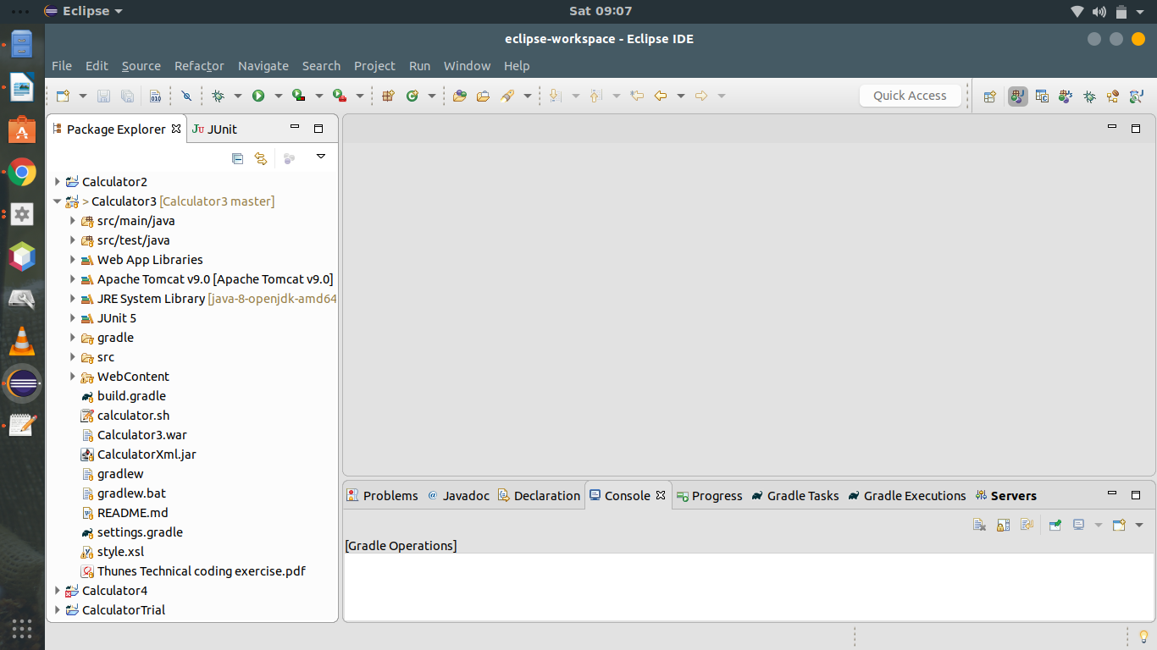

To run the project right click on it >Run as >Run on Server>Select your Tomcat instance> Finish

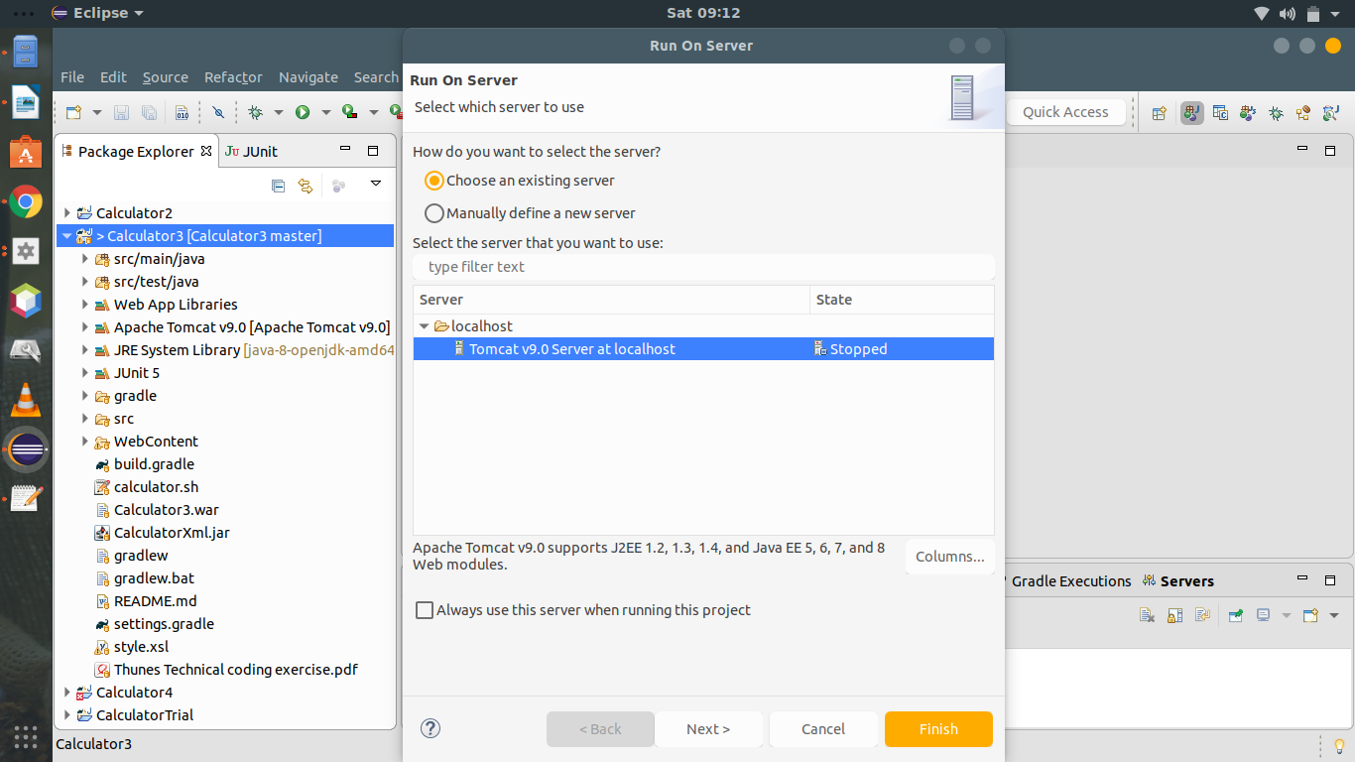

It should show a default Index page as shown below with some instructions

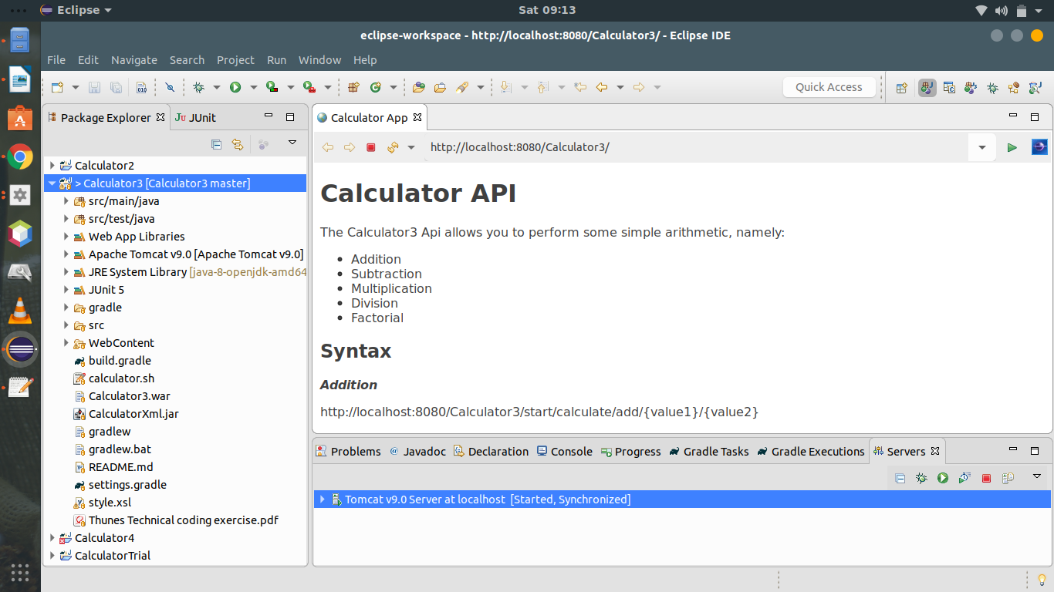

You can copy paste one of the examples shown in your chosen web browser to see if it works.

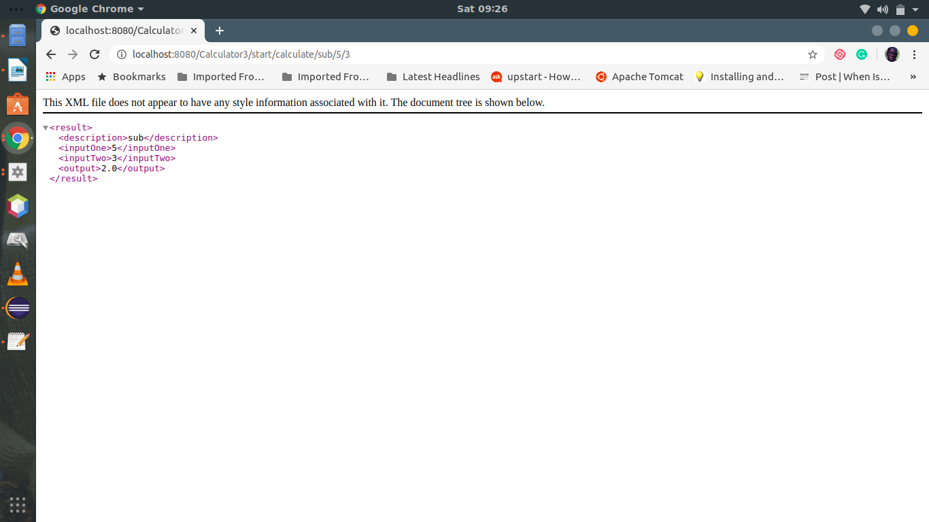

The syntax for running a calculation is:

{$TOMCAT_PATH}/Calculator3/start/calculate/{$ACTION}/{$VALUE1}/{$VALUE2}

e.g

[http://localhost:8080/Calculator3/start/calculate/add/5](http://localhost:8080/Calculator3/start/calculate/fac/5)/5

valid ACTION options = add sub mul div fac

Note: for Factorials (fac) only value1 is used

<http://localhost:8080/Calculator3/start/calculate/fac/5>

**Run Without Eclipse**

To run Calculator3 without eclipse deploy the war file bundled in the project folder **Calculator3.war** to your chosen Server Provider ,Tomcat,Jboss,Glassfish etc.

On Tomcat,

Navigate to the Manager App option and Upload the war file.

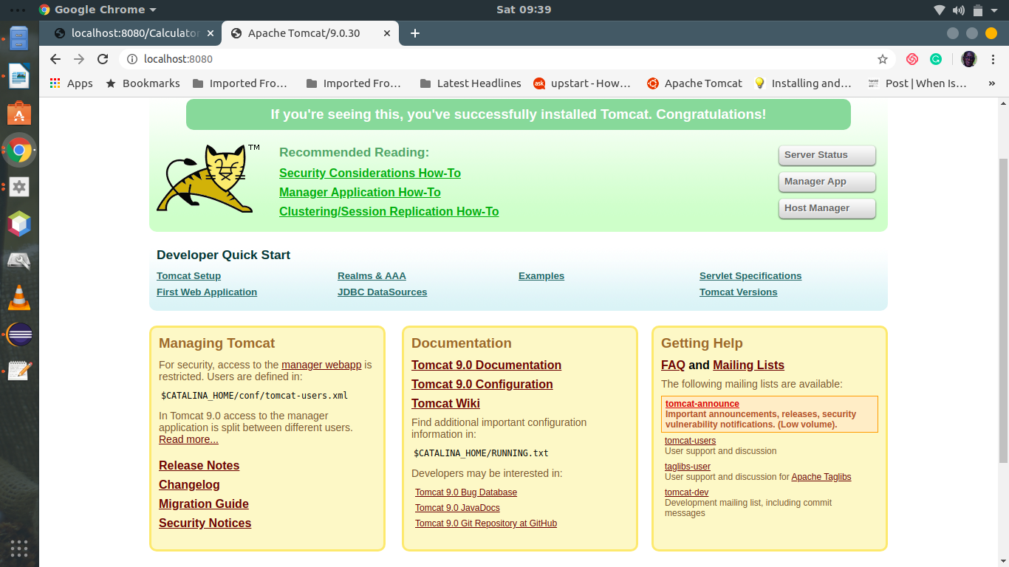

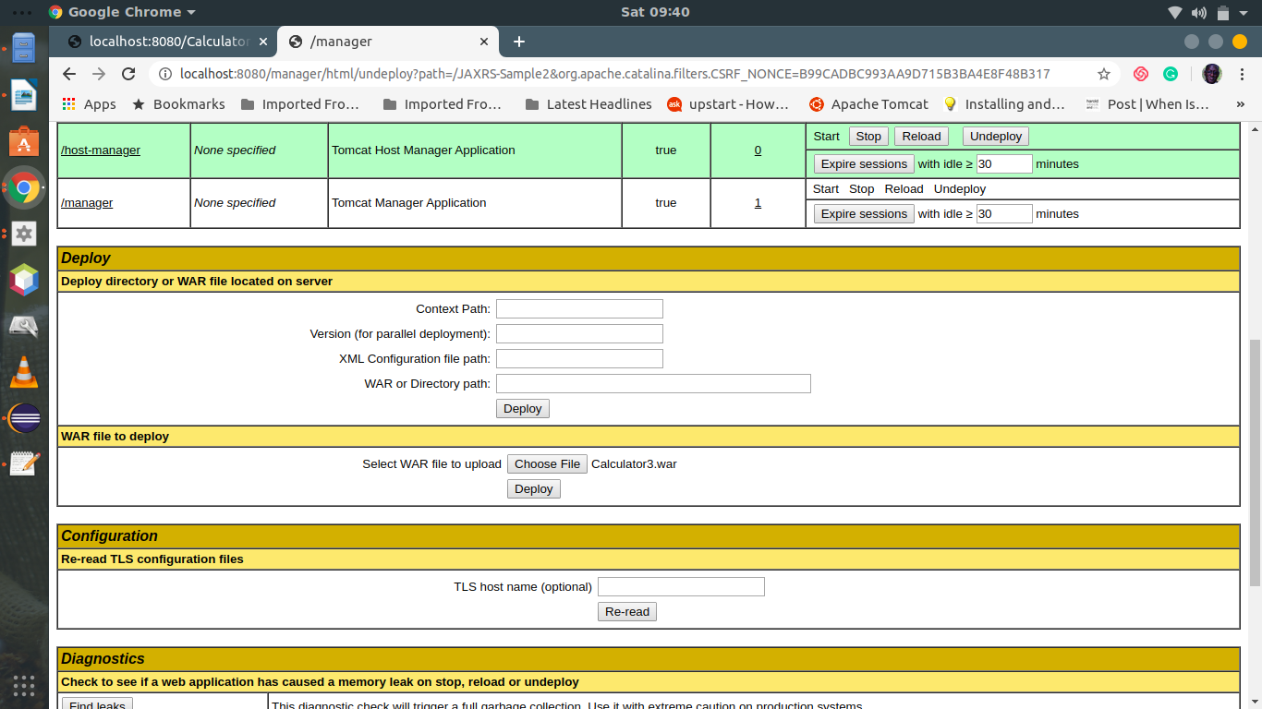

To test the deployment pass the following uri

<http://localhost:8080/Calculator3/>

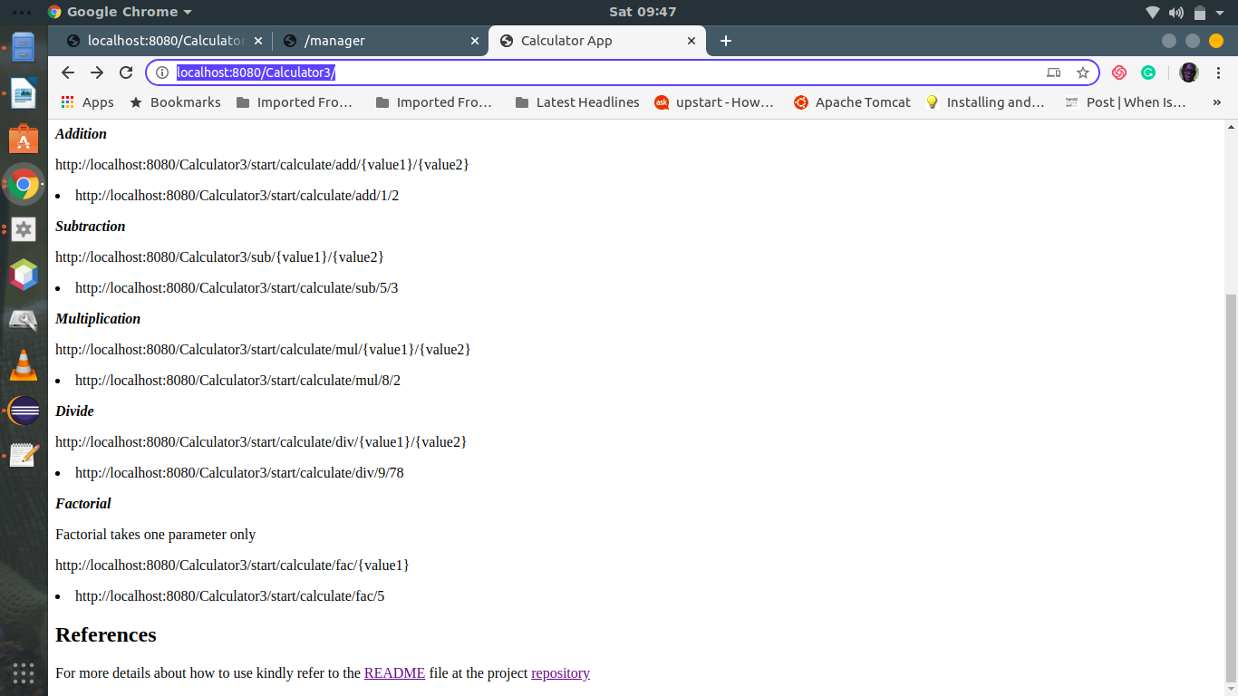

**Running Calculator3 from CLI**

You can run Calculator3 directly from the Command line using the curl utility as follows

curl <http://localhost:8080/Calculator3/start/calculate/fac/5>

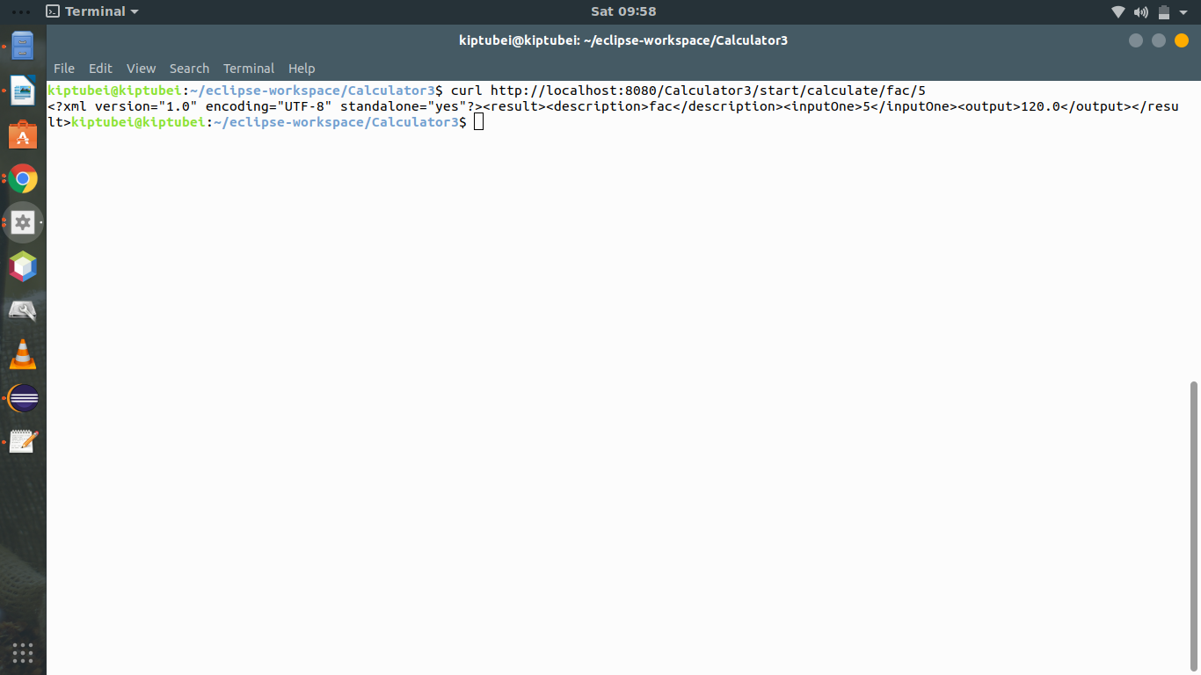

But the output is not very clear .

A better approach is to use calcultor.sh script bundled with the project Calculator3

as follows, from the project folder:

Edit calculator .sh ,change TOMCAT_PATH to match your installation

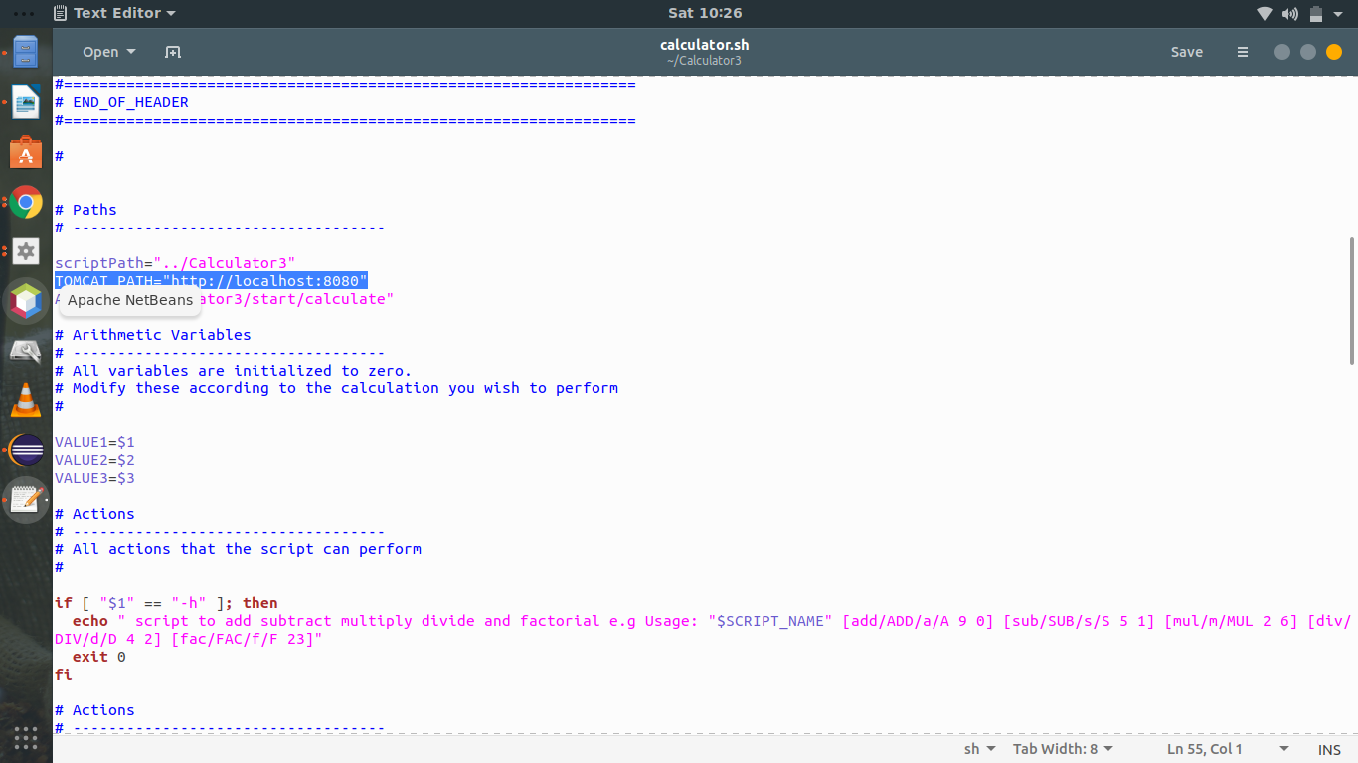

**./calculator.sh fac 5**

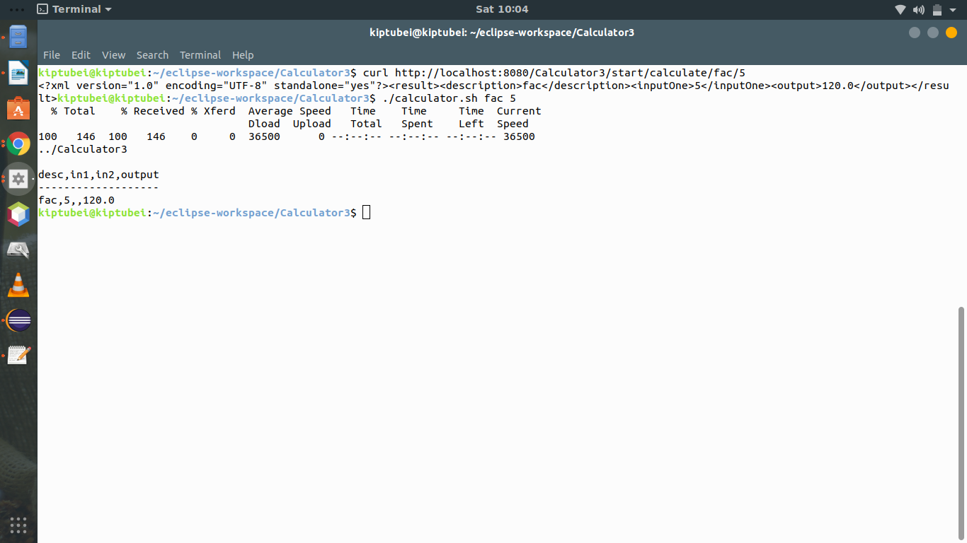This instructs Calculator3 Api to calculate the Factorial of 5 and the output is formatted by the script and displayed to the user . The script also keeps track of calculations done during that session.

**./calculator.sh mul 50 250**

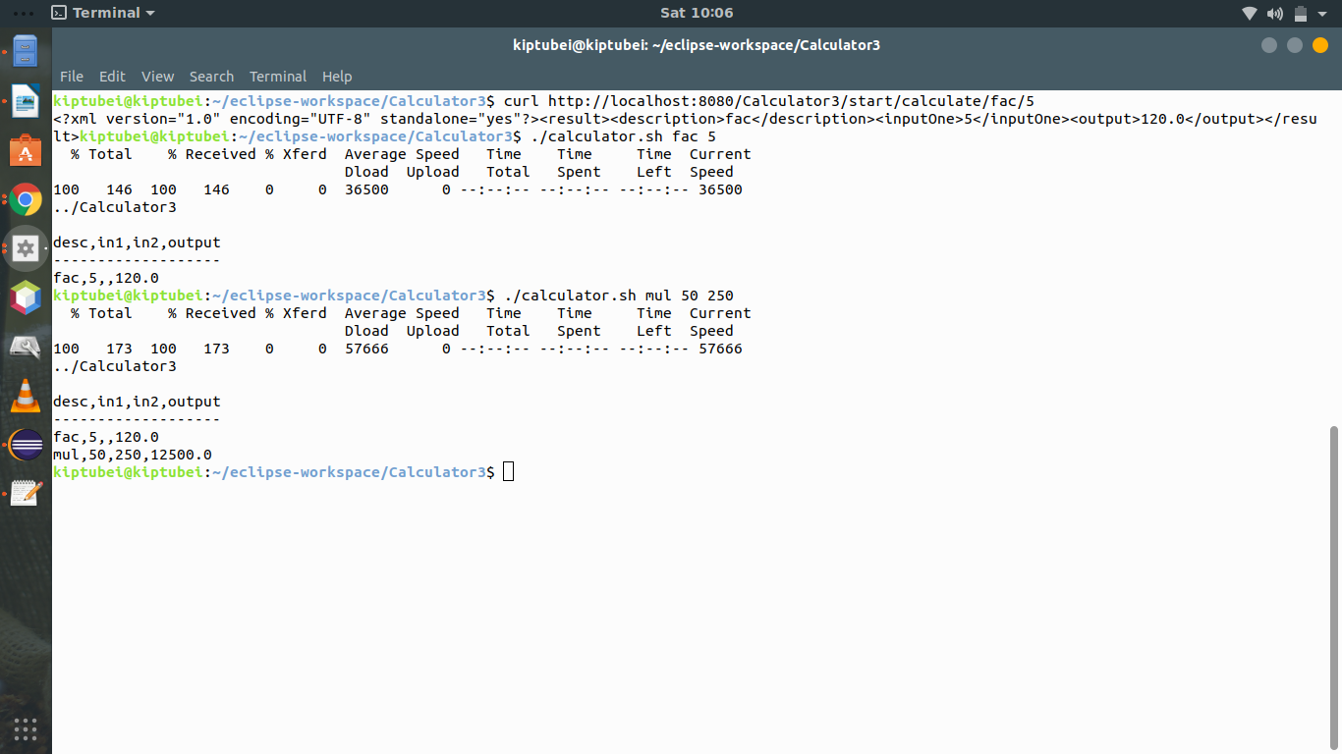

**Commands for calculator.sh**

./calculator.sh {$ACTION} {$VALUE1} {$VALUE2}

./calculator.sh [add,ADD,a,A] | [sub,SUB,s,S] | [mul,MUL,m,M] | [div,DIV,d,D] | [fac,FAC,f,F] | [-h] [VALUE1] [VALUE2]

**addition**

./calculator.sh add 7 8

./calculator.sh a 6 9

./calculator.sh A 6 9

./calculator.sh ADD6 9

**subtraction**

./calculator.sh sub 7 8

./calculator.sh SUB 6 9

./calculator.sh s 6 9

./calculator.sh S 6 9

**multiply**

./calculator.sh mul 7 8

./calculator.sh m 6 9

./calculator.sh M 6 9

./calculator.sh MUL 6 9

**divide**

./calculator.sh div 7 8

./calculator.sh DIV 6 9

./calculator.sh d 6 9

./calulator.sh D 79 89

**factorial**

**./**calculator.sh fac 5

./calculator.sh FAC 5

./calculator.sh F 7

./calculator.sh f 60